CS/EE 120B

Custom Project: Hangman

Ashly Hernandez

February 10, 2018

Introduction

Hang man is a two-player game. The first player picks a word for the second payer to guess. The second player only knows how many letters are in the word. The second player has to guess the word by picking letters. Every right letter has no penalty. Every wrong letter, they lose a life and one part of the stick figure is drawn. The stick figure consists of a head, body, two arms and two legs. Once the stick figure is complete (at the sixth wrong word) the second player loses the game. Every time the player gets a wrong letter, a buzzer sounds and an LED lights up. Once the game is started, a timer starts and stops once the game is won. The lowest time is saved as the high score.

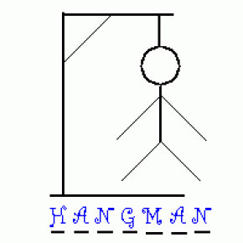

Components (Pin-out)

* **Inputs**
  + 4X4 Matrix Membrane Keypad for letter inputs
  + Reset and start buttons
* **Outputs**
  + Nokia 5110 LCD screen to display the game
  + LED to display user input
  + Sound buzzer for wrong answer
  + LED for wrong answer

Keypad

Buzzer

LED

Start

Reset

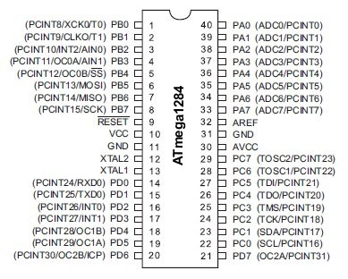

Nokia 5110 LCD

LED screen

Complexities/Build-upons

1. Using the Nokia 5110 LCD screen to display the hangman screen
2. Using the 4x4 keypad for alphabetical input

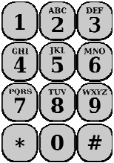

**have input stored for player one DONE

1. Using the EEPROM to save the lowest time
2. Showing a special character (stick figure) on the LED screen